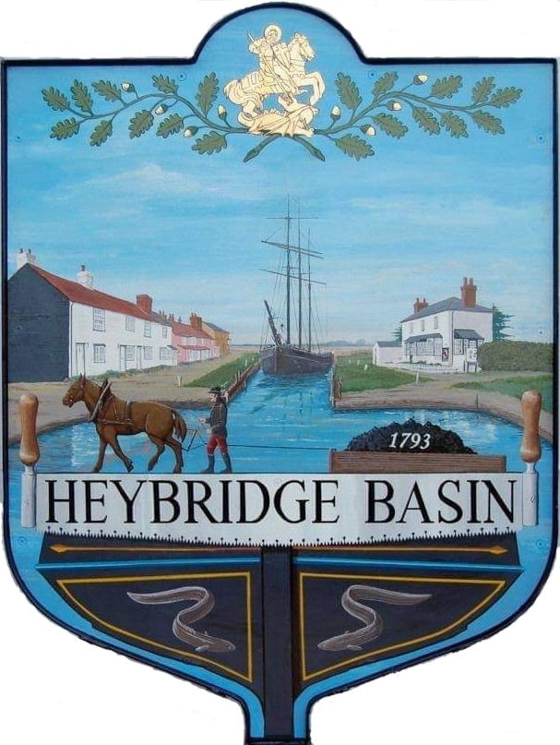

HEYBRIDGE BASIN PARISH COUNCIL

Minutes of the Full Council meeting of Heybridge Basin Parish Council held on Tuesday 14th November 2023 at 6.30pm, at The Lock Tea Room.

PRESENT

In the Chair: M. Hodges Apologies: C. Swann
J. Sjollema
Councillors: M. Hobden C. Edmond
R. Bryson
G. Howat District Councillors: N. Spenceley
Absent: 0 Officers: G. Lake – Clerk

Public: 0

It was noted that this meeting was being recorded by the Clerk.

23/102 Chair’s Welcome
Cllr Hodges opened and welcomed everyone to the meeting. It was reported that the Act of Remembrance hosted by the Parish Council on Saturday 11th November 2023 was well attended. A special thanks was given to the Stitch, Knit & Natter group for creating a lovely display, and for raising £600.00. Cllr Hodges had also attended the Heybridge Parish Council Service on Sunday 12th November 2023 and laid a wreath on behalf of Heybridge Basin Parish Council. Cllr Hodges informed members that he had completed the second day of Councillor training. Cllr Hodges also reminded members of e-mail etiquette.

23/103 Apologies for Absence.
Apologies were received from Cllrs Swann, Sjollema and Edmond.

23/104 To receive Declarations of Interest in accordance with the Council’s Code of Conduct and with section 106 of the Local Government Finance Act 1992.
Cllr Hobden – Non-Pecuniary – HBSA, Basin Oars and HB Rivercare; Cllr Howat – Non-Pecuniary – HBCSA

23/105 To sign as a correct record the minutes of the full council meeting held on 17th October 2023.
The Minutes as previously circulated were agreed as a correct record.

23/106 To sign as a correct record the minutes of the Budget meeting held on 3rd November 2023.
The Minutes as previously circulated were agreed as a correct record.

23/107 To receive a report from the District and County Councillors for the area on any matters of interest.
A report from the District Cllrs was received. No report from Cllr Durham.

23/108 Finance.
- To approve
- Payment requests for October/November 2023.
The Payments as previously circulated were approved.
- Receipts for October/November 2023.
The receipts as previously circulated were approved.
- To draft the Budget and consider setting the precept for 2024/2025.
Clerk informed members that the Precept Tax Base had not been received by Maldon, and that this would not be received until after 29th November. It was resolved to look into unmetered power supply rates and defer this item until the next meeting when more members are in attendance.

23/109 Public Forum
There were no members of public.

District Cllr Spenceley left at 06:45pm

23/110 Planning Applications
- To consider any planning applications received after the publication of the agenda and to agree the action to be taken.
There were no planning applications.

23/111 Pedestrian Sign St Georges
  - To receive an update from Cllr Hodges and agree any action to be taken.
Cllr Hodges had drafted and previously circulated a design and specification for the pedestrian sign. It was resolved that Cllr Howat would investigate potential wooden signs, and the Clerk would look into costings.

23/112 Turning Post
  - To discuss the turning post and agree any action to be taken.
The background of the Turning Post was discussed and that it was built for the Community to place memorial plaques onto it. It was resolved to research how the PC may adopt the post, and to discuss a policy at the next meeting.

23/113 Streetscape Design
- To receive a report from Cllr Howat and agree any action to be taken.
A report by Cllr Howat was received and noted.

23/114 Village Design Statement (VDS)
  - To receive an update from the Working Group
Cllr Howat reported that the WG had their first meeting in October, and that all members were reading the VDS in preparation for their meeting later this month.

23/115 On-Street Parking
- To receive an update from the Working Group
An update was received with relevant documents being circulated prior to the meeting. A 57% response had been received from the petition. It was resolved that Cllr Hodges would gather more responses and engage with those who raised concerns.

23/116 Daisy Meadow Car Park (DMCP)
- To receive an update from the Working Group and agree any action to be taken.
- tenders were received and were opened by Cllr Hodges, Cllr Bryson and the Clerk on Wednesday 1st November, a spreadsheet was created by Cllr Hodges and circulated to all members. It was resolved to seek quotes for a Civil Planner.

The planning application to remove the Laurels and Conifers on the left-hand side of the access road has been submitted.

Cllr Hodges put forward the idea of changing the DMCP Working Group to a sub-committee with delegated powers, which would involve amending the Personnel Committees Terms of Reference. It was resolved to Draft Terms of Reference for a DMCP Sub-Committee for Council’s consideration.

23/117 Community Speed Watch
- To receive an update from the Working Group and agree any action to be taken.
The Community Speed Watch training took place on Wednesday 8th November, 8 volunteers out of the 12 were in attendance. Online training is being organised for those who were unable to attend. It was resolved for the Clerk to create groups of volunteers and create a rota, and for the Speed Watch Group to commence as soon as possible.

23/118 Clerk’s Report
- Bicycle - The Bike was reported to the police, and as attempts had been made to locate the owner with no response, the bicycle belongs to the PC. Cllr Edmond has volunteered to take the bike for a Maldon Bike Group.
- CiLCA - The extension request had been approved and new deadline is 7th April 2024.
- Tesco Stronger Starts Results - The PC came second and have been offered £500.00 towards the costs of the basketball hoops. A form needs to be completed prior to 1st December.
- Interim Audit - The Interim Audit is taking place on 7th December 2023, so the Clerks main priority will be to prepare for the Audit, therefore Council needs to be mindful.
- Hedges along Basin Road – Clerk had been informed that work had been completed, but it appears it was only the grass that was strimmed. Clerk will still contact Canterbury Farm and Essex Highways to ascertain correct ownership. It was resolved to continue seeking quotes.

23/119 Correspondence
- To note correspondence received and any actions to be taken.
Correspondence was noted and responses were agreed.

Cllr Hobden left at 07:51pm

It was resolved to purchase a £25.00 voucher from the Tea Room and donate it to Heybridge Primary School PTFA for their Christmas raffle.

23/120 Local Issues
- To note any items of inclusion on the agenda for the next meeting of the Parish Council.
There were none.

23/121 Pursuant to section 1(2) of the Public Bodies (Admission to Meetings) Act 1960 it is resolved that, in view of the confidential nature of the business about to be transacted, it is advisable in the public interest that the press and the public be excluded, and they are instructed to withdraw.

There were no members of public to exclude.

23/122 National Pay Award
- To receive and note the settlement of the National Pay Award for 2023/2024.
The settlement of the National Pay Award for 2023/2024 was received and noted.
- To agree that the back-dated National Pay Award for 2023/2024 be paid to the Clerk from 1st April 2023 within December pay roll.
It was agreed to pay the Clerk the back-dated National Pay Award for 2023/2024 from 1st April 2023 within December pay roll.

23/123 DMCP
- To discuss the management of the car park and agree any action to be taken.
A discussion was held. It was resolved to research options regarding the management of the car park.

There being no further business the meeting closed at 08:18pm
Provisional Date of the next Council Meeting Tuesday 12th December 2023.

Clerk Contact details: clerk@heybridgebasinpc.org.uk
Website: www.heybridgebasin-pc.gov.uk

